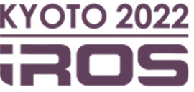
SPONSOR/EXHIBITOR APPLICATION FORM

IEEE/RSJ INTERNATIONAL CONFERENCE ON INTELLIGENT ROBOTS AND SYSTEMS
October 23-27, 2022 | Kyoto, Japan

- Please read this application form carefully, and complete, sign and return the form to exhibition@iros2022.org

General Information

Company Name ( )

Contact Person ( ) E-mail ( )

Tel ( ) Fax ( )

Mailing Address ( )

City ( ) Country ( ) Postal Code ( )

Billing Data (if different from above)

Company Full Name ( )

Mailing Address ( )

City ( ) Country ( ) Postal Code ( )

IROS2022 | October 23-27, 2022 | Kyoto, Japan

IEEE/RSJ INTERNATIONAL CONFERENCE ON INTELLIGENT ROBOTS AND SYSTEMS
October 23-27, 2022 | Kyoto, Japan

Sponsorship Package

 | Type | JPY |  | Type | JPY
 | Diamond | 5,000,000 |  | Platinum | 3,000,000
 | Gold | 1,800,000 |  | Silver | 1,200,000
 | Bronze | 500,000 |  | Booth Only | 300,000
 | Online Diamond | 1,500,000 |  | Online Platinum | 1,200,000
 | Online Gold | 1,000,000 |  | Online Silver | 500,000
 | Online Bronze | 300,000
Other (Please specify)

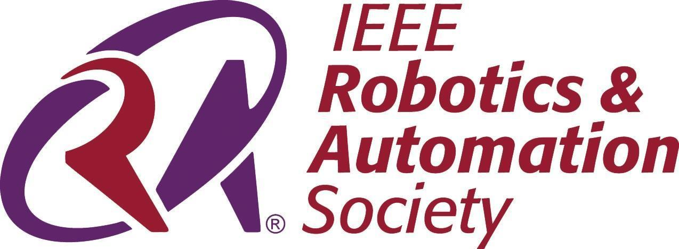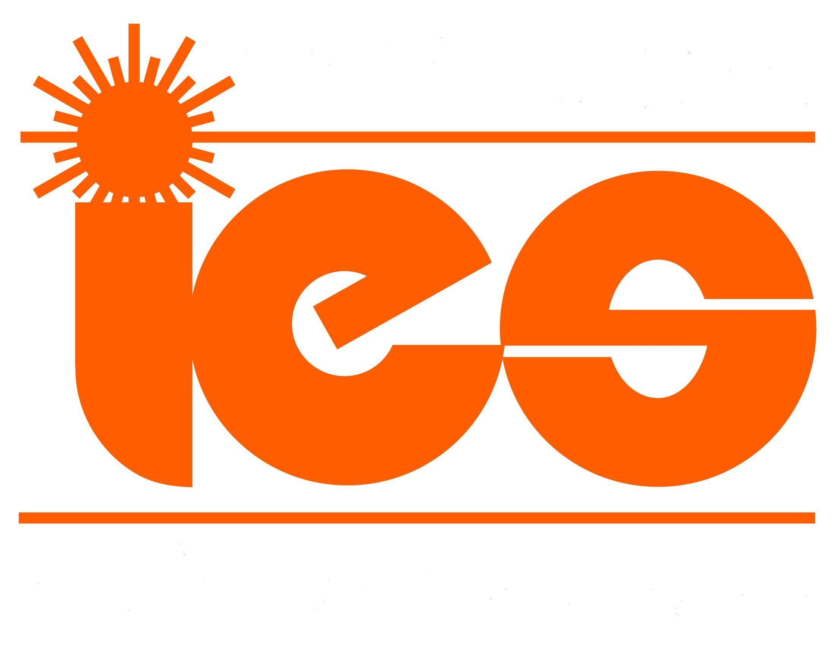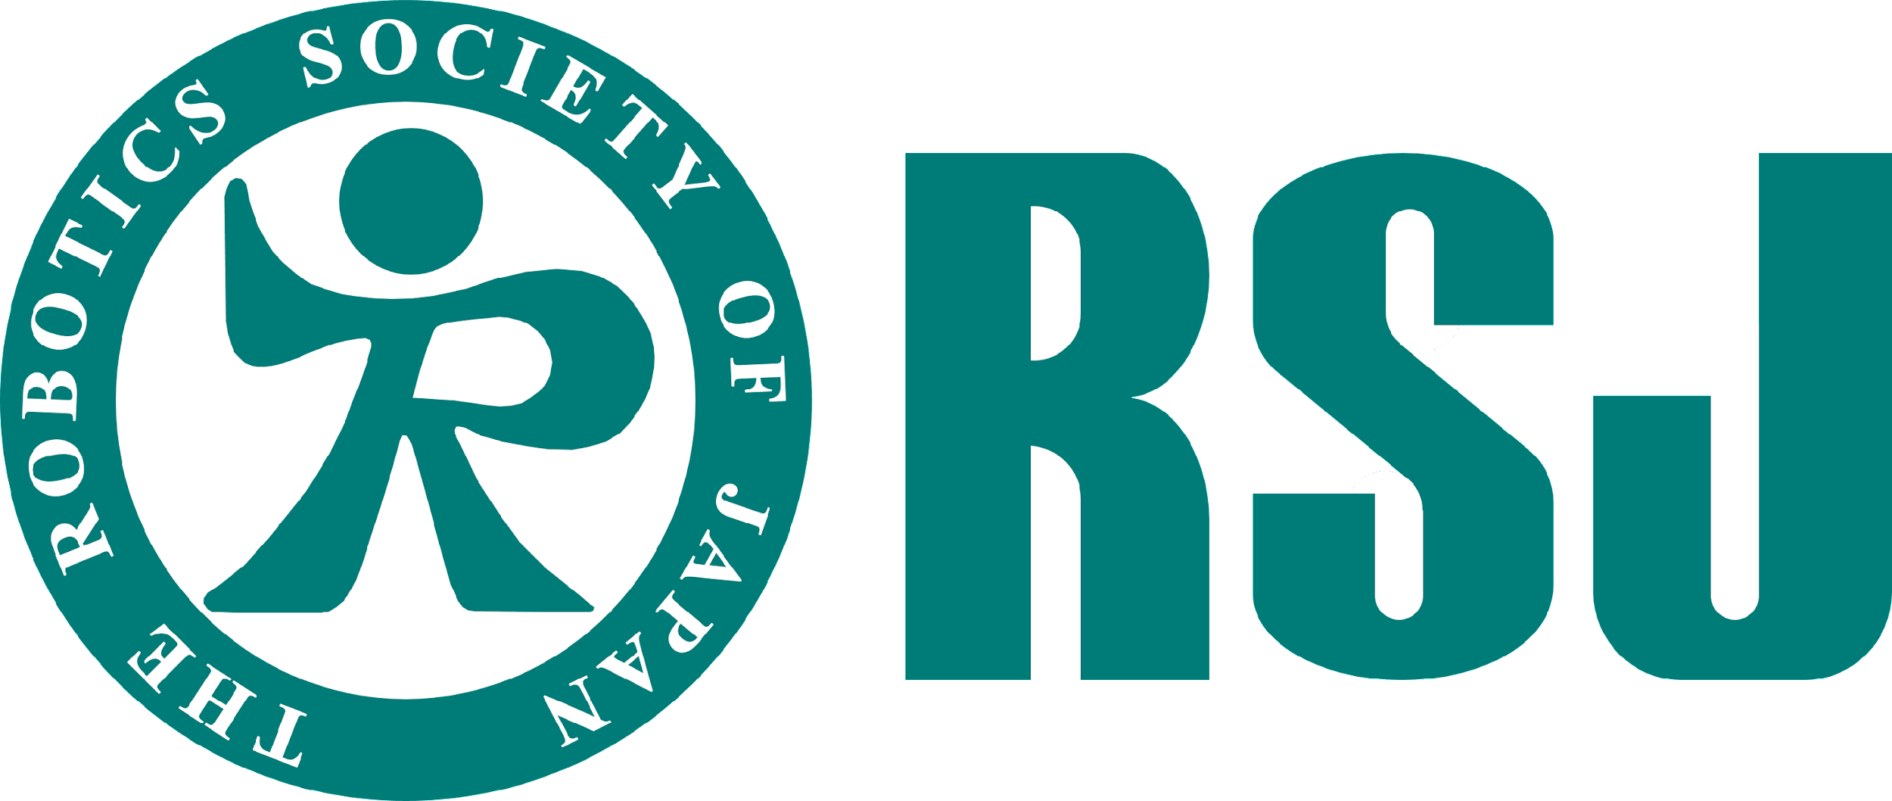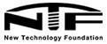
IROS2022 | October 23-27, 2022 | Kyoto, Japan

IEEE/RSJ INTERNATIONAL CONFERENCE ON INTELLIGENT ROBOTS AND SYSTEMS
October 23-27, 2022 | Kyoto, Japan

Additional Sponsorship Opportunities (Non-exclusive)

 | Type | JPY |  | Type | JPY
 | Plenary Speaker Sponsor | 2,000,000 |  | Keynote Speaker Sponsor | 1,000,000
 | Concurrent Session Sponsor | 350,000 |  | Conference Bag Sponsor | 600,000
 | Lanyards and Name Badge Sponsor | 600,000 |  | Conference Dinner Sponsor | 1,200,000
 | Welcome Reception Sponsor | 500,000 |  | Award Luncheon Sponsor | 250,000
 | Farewell Party Sponsor | 250,000 |  | Barista Sponsor | 250,000
 | Insert Sponsor | 120,000 |  | Room Name in the Conference Venue | 400,000
 | Free Social Event |  |  |  | 40,000
 | Additional Exhibitor Staff Badge |  |  |  | 25,000
 | Robot Competition |  |  |  | 100,000
Other (Please specify)

1. Your company will be recognized on signage onsite at the speciﬁc event you sponsor.
2. If your company would like to be an exclusive sponsor, please contact: exhibition@iros2022.org.
3. All applications are subject to Committee approval, the Organizing Committee reserves the right to decline sponsorship bookings at their own decision.
4. Please note that full payment of the total sponsorship is required within receipt of the sponsorship
application form.

Payment Information

Bank Transfer or Credit Card. Payment information will be notified after your application is accepted by the IROS 2022 organizing committee. Please contact Exhibition Chairs at exhibition@iros2022.org for payment information.

Signature and Company Chop Date

Oﬃce Use Only

Total Booth Space License Form Received

Booth Assigned Total Amoun
IROS2022 | October 23-27, 2022 | Kyoto, Japan

